|  |  |  |  |  |  |
| --- | --- | --- | --- | --- | --- |
|  |  |  |  |  |  |
| Faculdade |  |  |  |  |  |
| sigla | nome | prédio | orçamento |  |  |



|  |  |  |  |
| --- | --- | --- | --- |
| Professor | |  |  |
| id | nome | salário | siglaFacul |



|  |  |  |  |  |  |
| --- | --- | --- | --- | --- | --- |
| Estudante | |  |  |  |  |
| id | nome | dataNasc | CRA | idProf | siglaFacul |

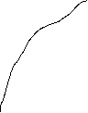

|  |  |  |
| --- | --- | --- |
| Sala |  |  |
| número | prédio | capacidade |



|  |  |  |  |
| --- | --- | --- | --- |
| Disciplina | |  |  |
| código | nome | créditos | siglaFacul |



|  |  |
| --- | --- |
| Semana |  |
| idSemana | descrição |

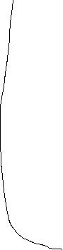

|  |  |  |
| --- | --- | --- |
| Horário |  |  |
| idHora | horaInício | horaFim |

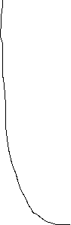

|  |  |  |  |  |  |
| --- | --- | --- | --- | --- | --- |
| Turma |  |  |  |  |  |
| turma | ano | semestre | códDisc | numSala | prédio |



|  |  |  |  |  |
| --- | --- | --- | --- | --- |
| Ensina |  |  |  |  |
| idProf | turma | ano | semestre | códDisc |



|  |  |  |  |  |  |
| --- | --- | --- | --- | --- | --- |
| Frequenta | |  |  |  |  |
| idEstudan | turma | ano | semestre | códDisc | nota |

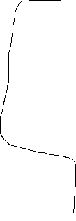

|  |  |
| --- | --- |
| Pré-Requisito | |
| códDisciplina | códPréRequisito |

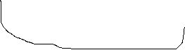

|  |  |  |  |  |  |
| --- | --- | --- | --- | --- | --- |
| Possui |  |  |  |  |  |
| idSemana | idHora | tuma | ano | semestre | códDisc |